Practical No. 2

Aim: Implement DDL and DML queries with different clauses.

Theory:
Implementing DDL (Data Definition Language) and DML (Data Manipulation Language) queries with different clauses is a fundamental aspect of working with relational databases. This practical theory provides an overview of how to practically implement these queries with various clauses to create, modify, and manipulate database structures and data.

Queries:
1) List the customer numbers (customer_no) and names (name) of all customers.
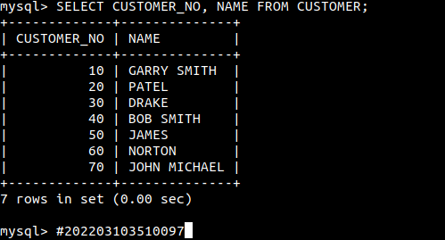

2) List all details of the product with a product number (product_no) of 121 and 136.
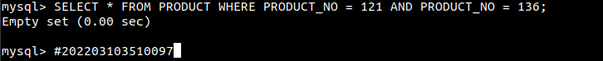

3) List all details of depots with rep 5 as their rep(rep_no).
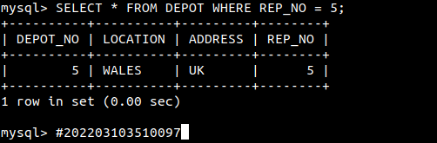
4) List the product number (product_no) and description only of all products from
supplier number 1005 (supplier_no).
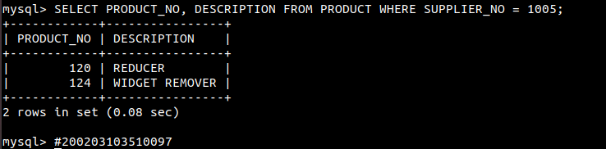

5) List all details for all customers with names (name) starting from sm followed by 1 character followed by t followed by anything.)


6) List all details for all orders with date_placed from 1-jan-2023 to 31-jan-12023).
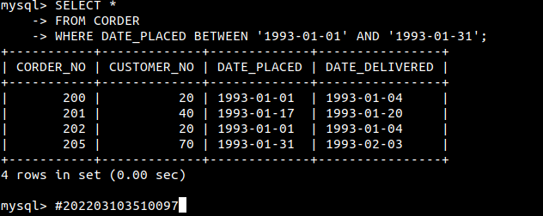

7) List the sales rep number (rep_no), depot number and address for depots located at
NORTH and address is UK.
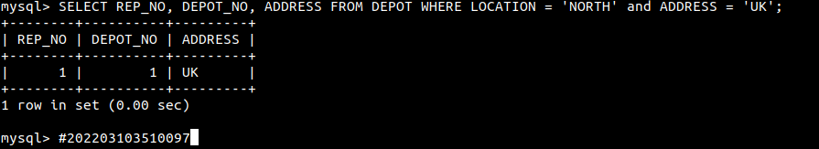

8) Give the total number of items (quantity) in stock in all depots.
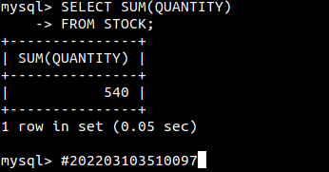

9) Give the total number of items (order line quantity) which have been ordered with
corder_no 200.
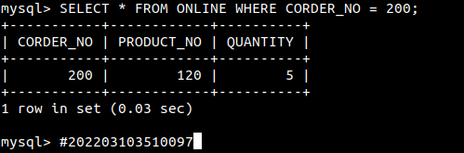

10) List product descriptions in reverse alphabetical order.
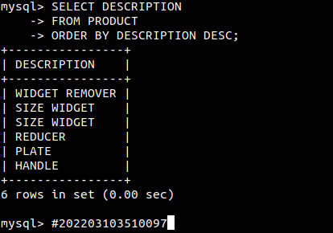

11) List the customer details with name ends with N.
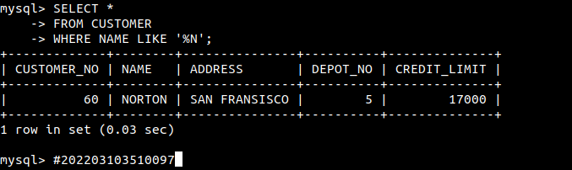

12) List the customers details with a CustomerName that have &quot;r&quot; in the second position:
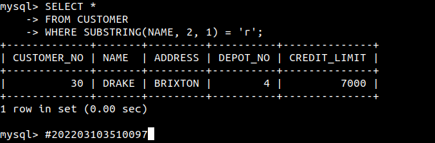

13) List the customers with a CustomerName that starts with &quot;N&quot; and are at least 4 characters in length.
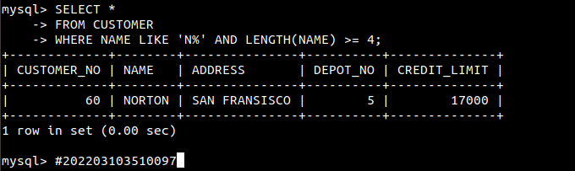

14) Find all suppliers with a City containing the pattern “ny”
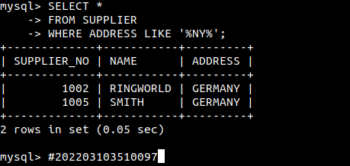

15) Selects all customers with a City starting with “L”, followed by any character, followed by “n”, followed by any character, followed by “n”
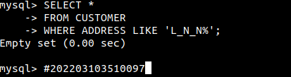

Conclusion: Implementing DDL and DML queries with different clauses is a fundamental skill for working with databases. This practical theory provides an overview of the key steps and considerations for effectively using these queries to create, modify, and manipulate database structures and data. Hands-on practice and continuous learning are essential for mastering these skills and becoming proficient in database management.

